**PRATICAL NO 8 :- Write a program using TCP socket for wired network for following**

**Client:**

import java.io.*;

import java.net.Socket;

import java.util.Scanner;

public class Client {

private static DataOutputStream dataOutputStream = null;

private static DataInputStream dataInputStream = null;

private static Scanner scanner = new Scanner(System.in);

public static void main(String[] args) {

try(Socket socket = new Socket("localhost",5000)){

dataInputStream = new DataInputStream(socket.getInputStream());

dataOutputStream = new DataOutputStream(socket.getOutputStream());

while (true) {

System.out.print("input> ");

String message = scanner.nextLine();

dataOutputStream.writeUTF(message);

if(message.equalsIgnoreCase("exit()"))

break;

}

}catch (Exception e){

System.out.println(e.toString());

}

}

}

**Server:**

import java.io.*;

import java.net.ServerSocket;

import java.net.Socket;

public class Server {

private static DataOutputStream dataOutputStream = null;

private static DataInputStream dataInputStream = null;

public static void main(String[] args) {

try(ServerSocket serverSocket = new ServerSocket(5000)){

System.out.println("listening to port:5000");

Socket clientSocket = serverSocket.accept();

System.out.println(clientSocket+" connected\n");

dataInputStream = new DataInputStream(clientSocket.getInputStream());

dataOutputStream = new DataOutputStream(clientSocket.getOutputStream());

String message;

while (true) {

message = dataInputStream.readUTF();

System.out.println(message);

if(message.equalsIgnoreCase("exit()"))

break;

}

clientSocket.close();

} catch (Exception e){

System.out.println(e.toString());

}

}

}

**Output:**

* 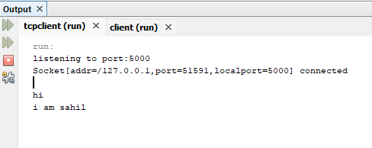**server:**
* **Client:**

